tools from a 3D printer

  - J. A. KOMENSKÉHO ELEMENTARY SCHOOL
  - Újezd 990,
697 24 Kyjov

Contents:
Annotation of the project 3
Objectives: 3
Financial calculation of the project 4
Preparation for 3D printing 7
Choosing a printer supplier 7
Sold versions of Průša printers and their evaluation. 8
Filament selection 10
Pre-made prints 11
School supplies shared on the internet 16
Relief map of the Czech Republic 17
Optical illusions – physics 20
Kazoo musical instrument 21
Custom creation of the model 22
Tinkercad 23
Cube 24
Ruler 28
SketchUp 30
Phone stand 30
Organiser 32
Connected vessels 33
Fraction calculator 34
Project output 36
Summary of work 37

Annotation of the project
The project is aimed at acquiring new knowledge and skills when working with new technologies of 3D printing, engraving and laser cutting. It aims at increasing the digital literacy of pupils and teachers. It takes the existing competence acquired by teaching informatics in the area of ​​planar two-dimensional vector graphics to the next dimension. Modelling in three-dimensional space is a new opportunity for transferring theoretical knowledge from the traditional way of teaching to a much more practical and illustrative level.
The technical equipment that the school will acquire through the implementation of the project is intended to continue to be used as an interest activity for pupils after its completion or to be directly implemented into the teaching concept of the so-called new informatics.

Objectives:
Pupils will learn to master 3D printing technologies and become familiar with the possibilities of putting them into practice at school by creating tools and 3D models.
They will learn to document the activity performed and explain the principles used.
Working in a group, they will learn to cooperate and divide tasks.
Pupils will learn that the appearance of products is also important, they will learn to create visually interesting works using their imagination and visual arts.
Pupils will learn to connect knowledge from different subjects and fields and use it to create specific tasks. They will learn to set goals, think through strategies for solving them and their subsequent presentation and usefulness in practice.

Financial calculation of the project
ID | School | Product | KS | Assumption | Realn price | State | Link
109 | Kyjov | i3 MK3S | 1 | 27 000,00 CZK | 26 990,00 CZK | submitted | https://shop.prusa3d.com/cs/3d-tiskarny/181-3d-tiskarna-original-prusa-i3-mk3s.html
109 | Kyjov | Laser engraver K3020 | 1 | 18 000,00 CZK | 18 450,00 CZK | submitted | http://www.laserstore.cz/produkt/laserova-gravirka-k3020-digi/
 |  | Ntb Dell Vostro | 1 | 17 882,59 CZK | 17 882,59 CZK | submitted
 |  | Mini assembled | 3 | 11 000,00 CZK | 33 000,00 CZK | submitted | https://www.prusa3d.com/cs/produkt/castecne-sestavena-3d-tiskarna-original-prusa-mini-4/
 |  | PPE | 3 | 200,00 CZK |  |  | https://www.madmatshop.cz/stanley-cervene-okuliare-pre-lasery-s-cervenym-lucom-p5954
 |  | PLA filament | 5 | 600,00 CZK | 3 000,00 CZK | submitted
TOTAL |  |  |  | 74 682,59 CZK | 99 322,59 CZK
 |  |  |  |  | 677,41 CZK

Project timeline
- Start of project activities: September 1, 2020
- During face-to-face classes (until October 15, 2020) meeting 1 x a week, content: basics of working in the 3D editor SketchUp, Tinkercad
- January 2021 takeover of the Original Prusa i3 MK3S 3D printer
- May 2021 takeover of Original Prusa MINI+ 3D printers
- September 2021 involvement of new students in the project in the form of a school club
It should therefore be noted that the direct work on the 3D printers itself covered roughly only the period from March to June 2021 due to the original time schedule.

Number of students involved
- At the beginning, 8 students in total, divided into 2 out of 4 classes of the 9th grade, due to the development of the pandemic, this choice later turned out to be inappropriate, they are leaving our school on 6/30/2021. These students basically implemented most of the activities arising from the project plan.
- From September 2021, the new 3D printing class will consist of pupils from grades 6-9. This year, we basically started from the beginning.

Content

Preparation for 3D printing

Choosing a printer supplier
There are a number of 3D printers from different manufacturers appearing on the market. One of the largest and most well-known is also the Czech manufacturer of Průša, PRUSA Research, a. s.
Advantages of purchasing Průša printers:
- Jednoduchý software
- All instructions in both English and Czech
- Quality support
- Large selection of printer types
- Simple software
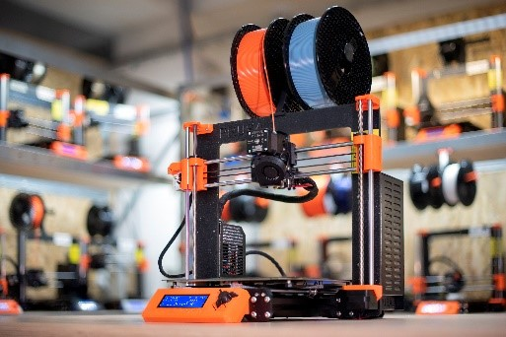

Sold versions of Průša printers and their evaluation.
The printer can be purchased already assembled (in our case it was the Original Prusa i3 MK3S type). This type of printer can be used immediately after unpacking and basic settings. Preparatory work takes approximately half an hour, after which the printer is ready to print.
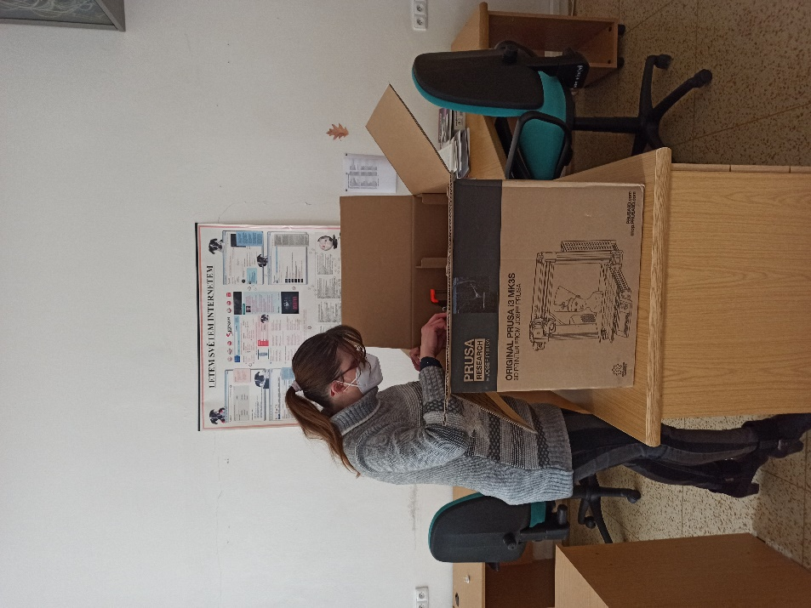
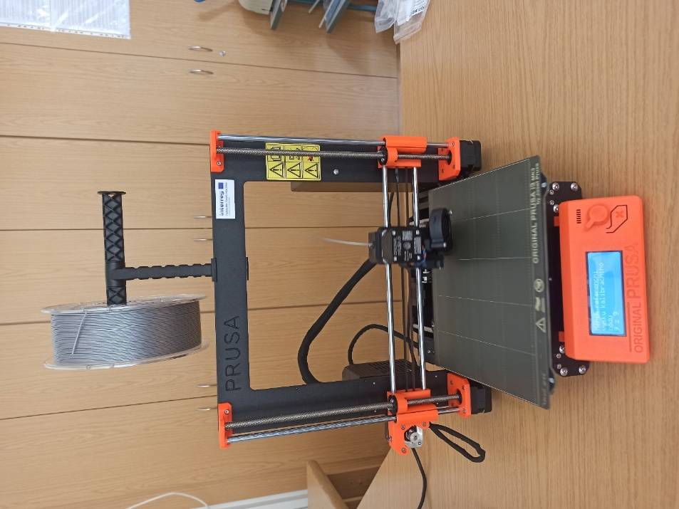
Instructions for putting the printer into operation here: Handbook (CZ)-Prusa i3 MK3S+ (3.15) (prusa3d.com)
The Průša company also offers cheaper 3D printer kits, or partially assembled versions such as the Original Prusa MINI+ purchased by us. This type of printer must first be assembled using the instructions. The video instructions are also very well made, so the kit is also suitable for beginners or older children. The entire assembly process takes approximately 1.5 hours, after which the printer needs to be calibrated. The disadvantage is that it takes more time and the possibility that the printer will be assembled incorrectly. On the contrary, the advantage is a more favourable price and its composition is interesting to children.
Instructions for putting the printer into operation here: prusa3d_manual_mini_cz.pdf
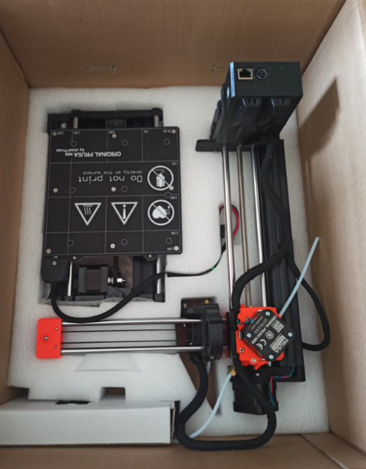
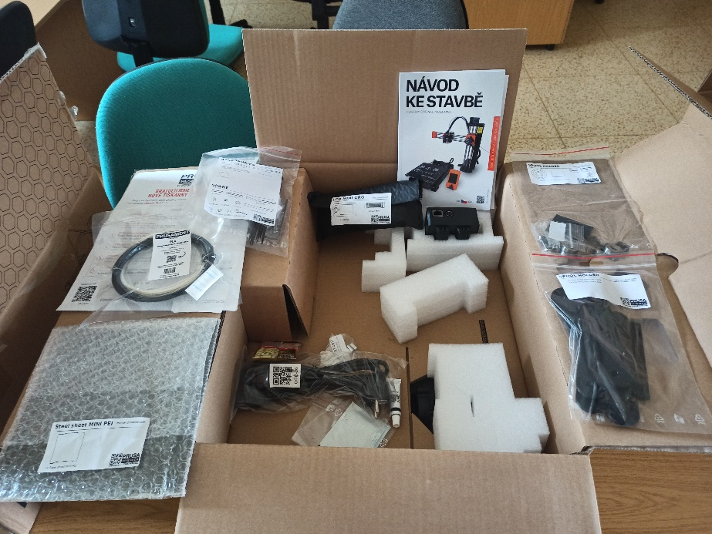
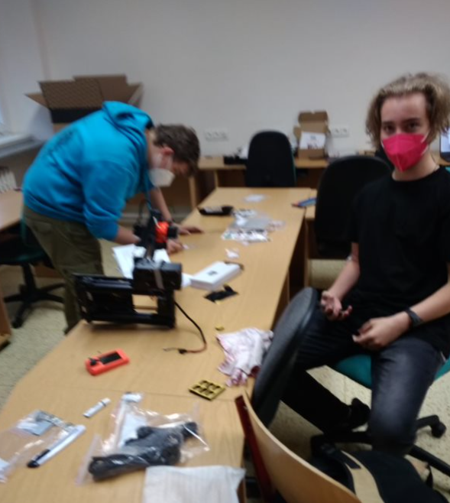

Filament selection
There are a large number of filaments for 3D printing, they are: PLA, PETG, ABS, ASA, TPU, Nylon, HIPS, PVA, and others.
PLA
Advantages: very hard, easy to print, good visual quality, is the most common filament used for 3D printing, and is environmentally friendly. Its disadvantage is that, although it is durable, it is more fragile than ABS.
ABS
The advantage is that it is very hard and resistant to high temperatures. However, ABS, unlike PLA, requires a heated print bed. It then smells when printing, which can be irritating.
PETG
It is strong, durable and can withstand higher temperatures. It combines the properties of PLA and ABS, it is odourless.
ASA
It is very durable, including impact resistance. It is more resistant to weather effects and UV radiation. However, a higher temperature is required for printing than with PLA.
We chose the PLA material for our printing, the reason was primarily simple printing, where the material does not require high substrate temperatures and no odour is produced. The created prints are very nice, compact, smooth to the touch.
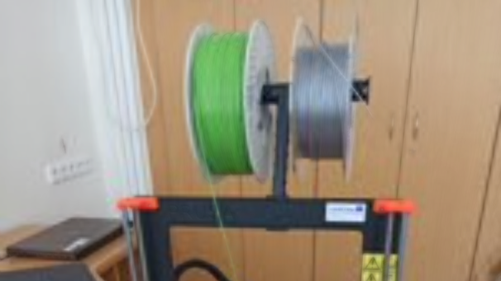

Pre-made prints
Beginners at printing will appreciate that it is possible to find a large number of ready-made models on the internet, which even a complete beginner can easily download and print. In the first meetings of our team, we set ourselves the task of discovering these resources and getting to know each other. We came across a number of websites functioning as libraries, databases or catalogues of ready-made 3D objects.

- www.thingiverse.com
- www.stlfinder.com
- www.cgtrader.com
- www.myminifactory.com
- www.3dagogo.com
- 3dwarehouse.sketchup.com
- cults3d.com
- pinshape.com
- www.youmagine.com
- 3dexport.com
- 3d-gallery.xyzprinting.com
- free3d.com
- fab365.net
- 3dkitbash.com
- www.yeggi.com
- digilab.dremel.com/resources/lesson-plans
- polar3d.com
- www.threeding.com
- www.redpah.com
- library.zortrax.com
- www.rinkak.com/jp/?hl=en
- www.shapetizer.com
- repables.com
- libre3d.com
- zheng3.com/forge/
- www.stlhive.com
- sketchfab.com
- 3dmag.org
- www.rascomras.com
- grabcad.com
- www.instructables.com
- 3dlabprint.com
- 3dprint.nih.gov
- nasa3d.arc.nasa.gov/models/printable

Closely related to the topic of our project is also the database of models of teaching aids located directly on the main page for printers Průša – Education | PrusaPrinters. The library of 3D models is the result of the ongoing Průša to schools program. How to use 3D printing in teaching - Prusa Education (prusa3d.cz)

In the first phase of working with a 3D printer, the students mastered the basic procedure, when each of them personally tried:
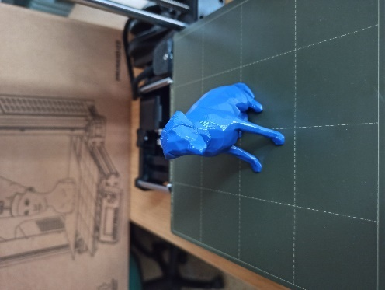
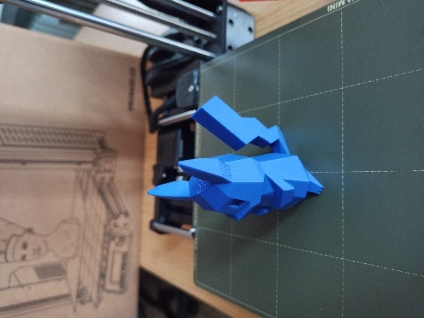
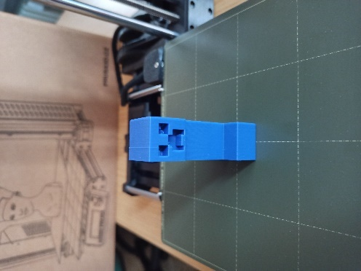
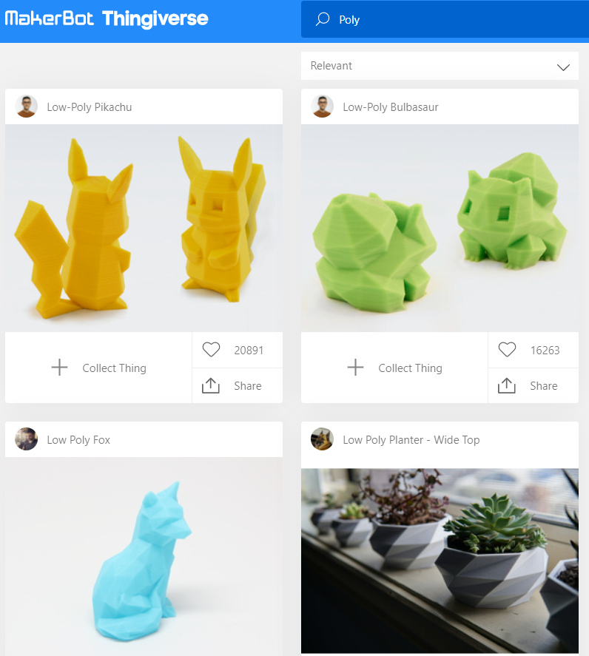
- Finding a simple ready-made object for printing. The site https://www.thingiverse.com/ with popular game, animated and movie characters has become the most popular source. Polyhedral models prevailed most often, which can be easily searched by entering the keyword (Tag) Poly.

- Save the file in. stl format to your computer
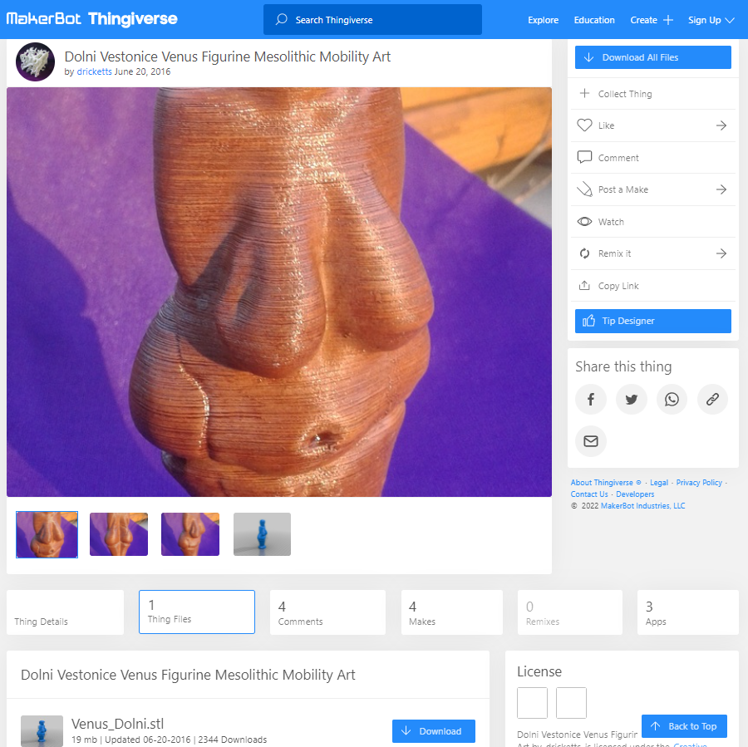

- Opening the file in the program (in our case PrusaSlicer) for displaying and possibly editing the model, setting print parameters, slicing (cutting the model into individual printable horizontal layers) and creating (exporting) a 3D object to a. gcode file.
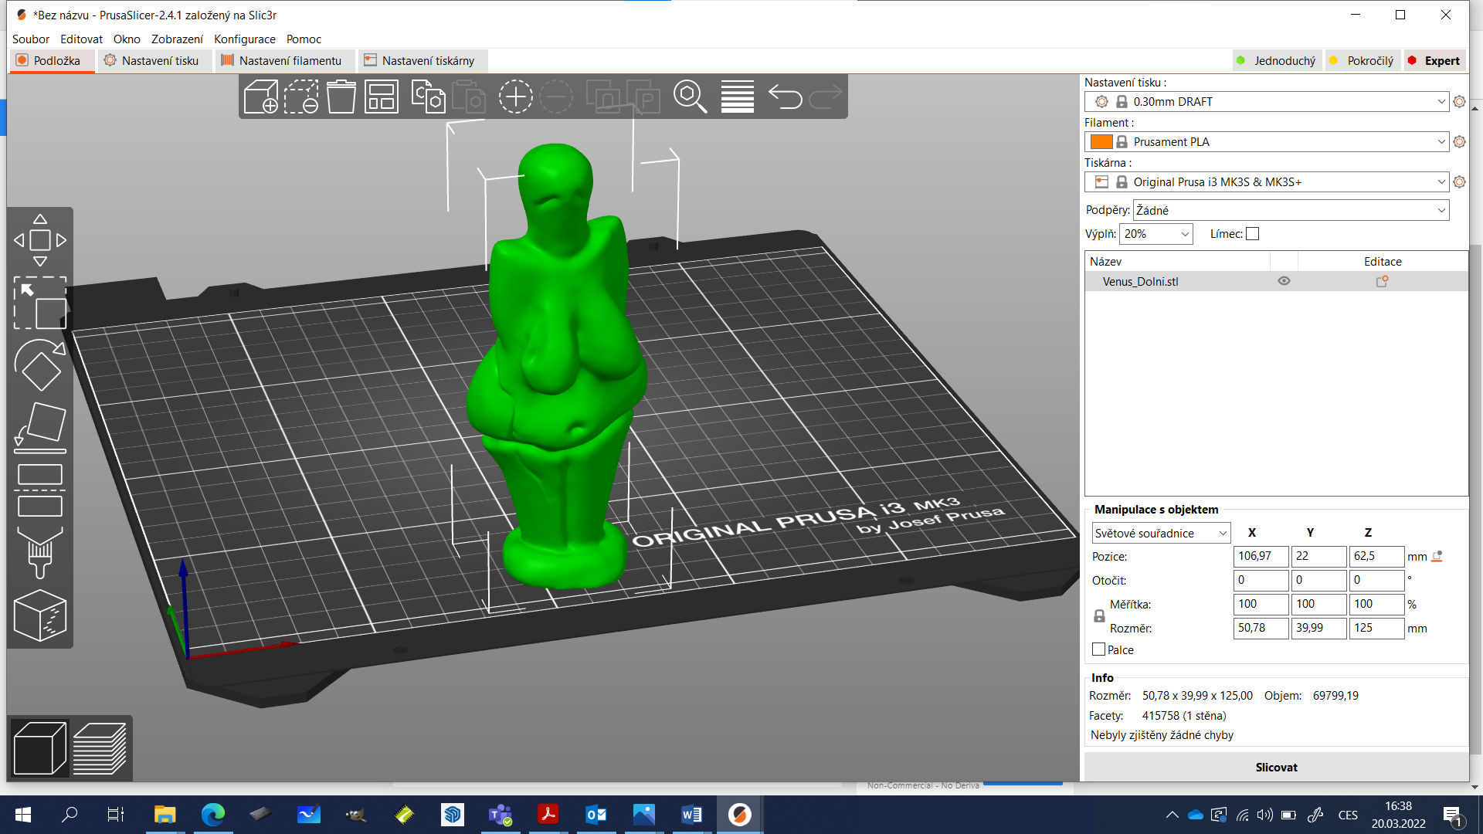
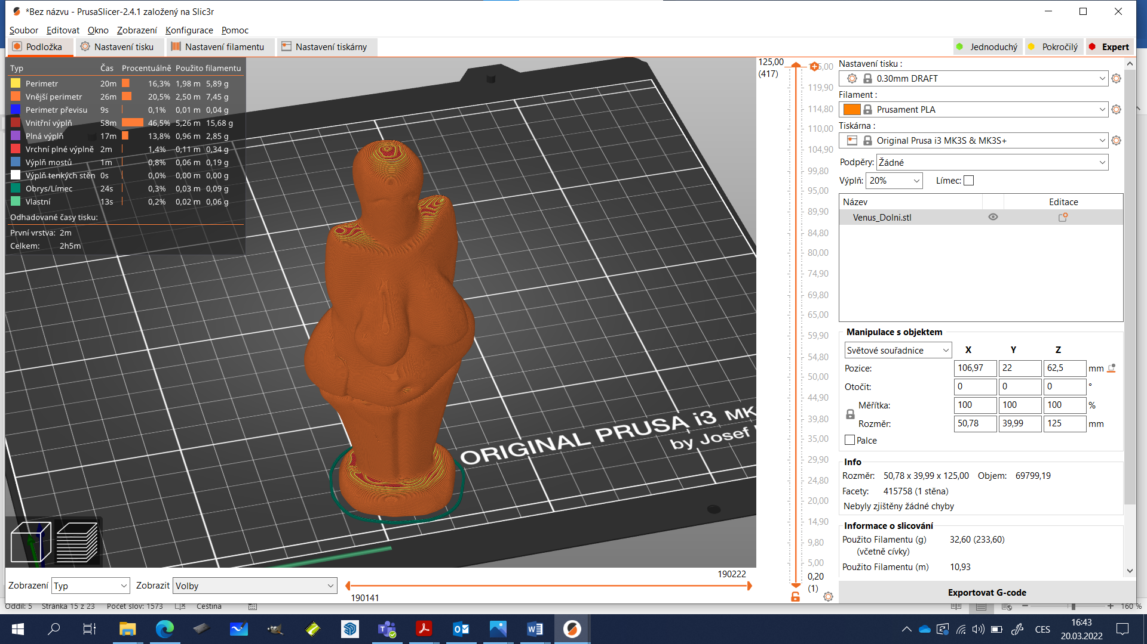

- Save the .gcode file to an SD card or USB drive
- 3D printing of the .gcode file from an SD card or USB drive (or sending via cable - not recommended)
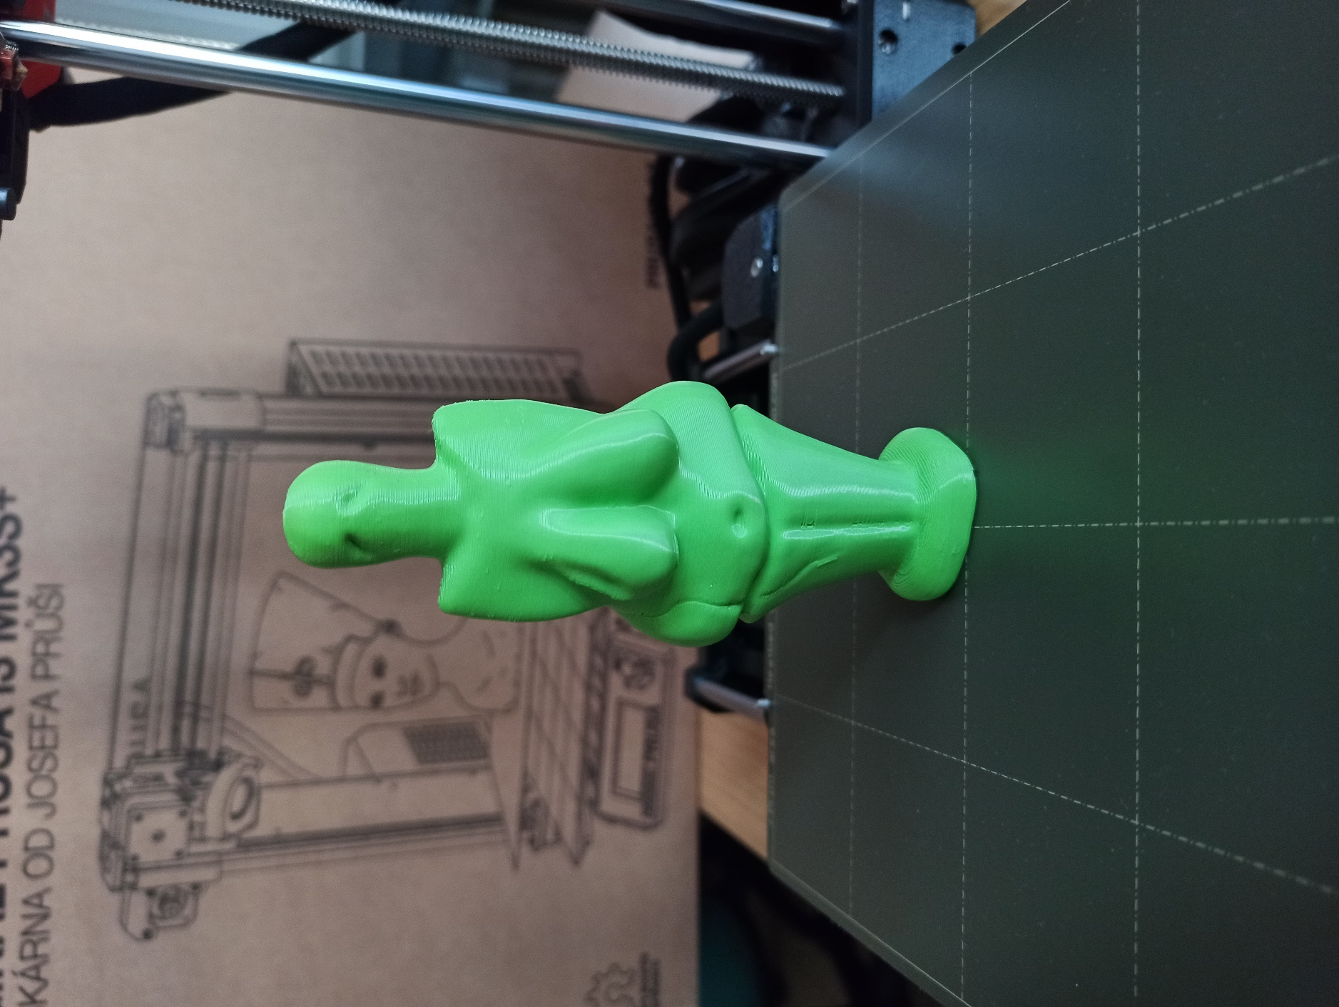

School supplies shared on the internet
As can be seen from the example of the Venus from Vestonice model, a number of tools from a 3D printer have already been realised and offered for sharing on the Internet. The team and I thought about what kinds of school supplies could still be considered for individual subjects:
Mathematics
- models of movable planar structures (bases of 3D bodies), geometric bodies, sections of bodies
- geometric verifications of mathematical statements (Pythagorean theorem)
- jigsaw puzzles of different shapes
- content, volume units
- puzzles, jigsaw puzzles
History
- models of important buildings and dwellings
- sections of buildings
- historical artefacts (Venus from Vestonice)
- (weapons, armour, jewellery, crown jewels, coats of arms...)
Geography
- territorial units (parts of the world, states, regions, districts, cities...), terrain reliefs
- models of important world buildings rebuildable city models
Chemistry
- models of atoms, models of molecules
- periodic table of elements
Natural history
- cell models,
- models of mineral crystal systems
Physics
- optical illusions
- joined vessels
Music
- treble clef, bass clef
- sheet music as figures
- musical instruments (ocarina, flute, kazoo), guitar picks
Informatics
- stand, mobile phone holder
Gymnastics
- whistles
- trophies for awards
- score indicators
We tried to implement some of the above examples of models, either by searching for a similar solution on the internet or by doing our own 3D modelling.

Relief map of the Czech Republic
Instructions for implementation: https://blog.prusaprinters.org/cs/jak-vytisknout-svet-nejen-okolo-nas-na-3d-tiskarne_29117/ 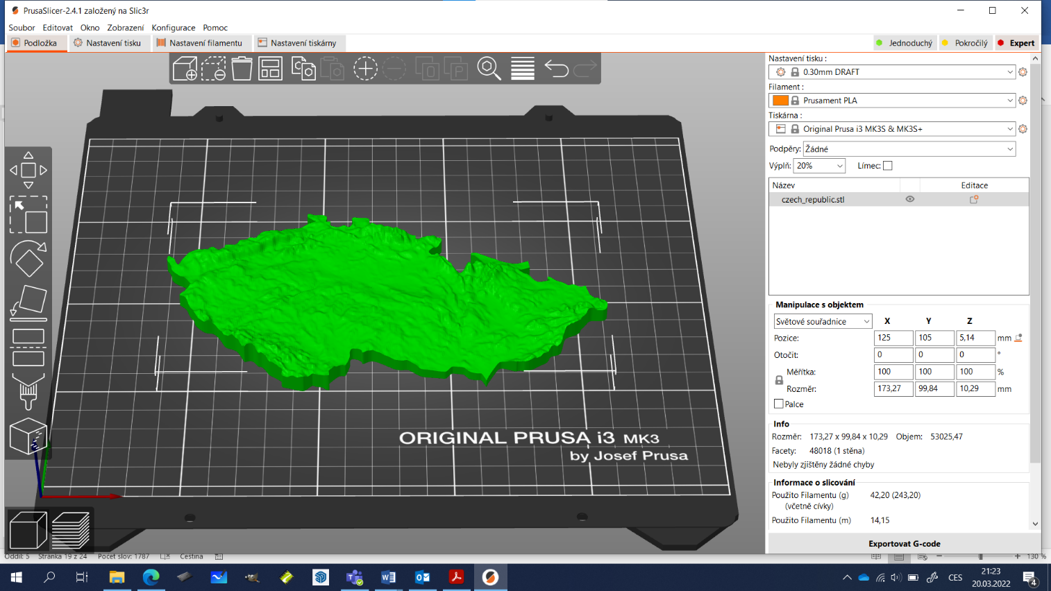
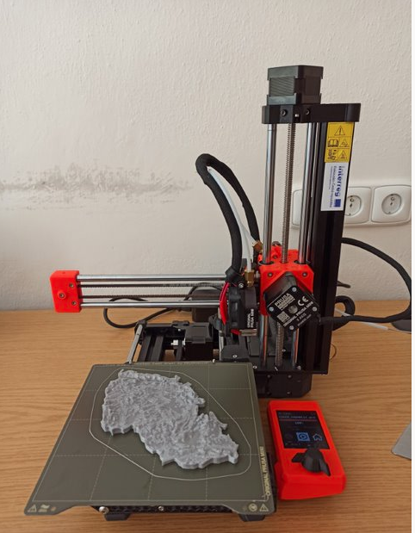
When printing the relief map of the Czech Republic, uneven and discontinuous filament extrusion occurred. The print showed gaps and missing layers, which we addressed by running the automatic Nozzle Cleaning process. This procedure proved to be insufficient and it was necessary to supplement it by cleaning the filament feed wheels and finally by using the Cold Pull method to remove all remnants of the filament.
Detailed instructions here: https://help.prusa3d.com/cs/article/ucpana-tryska-hotend-mini-mini_112011
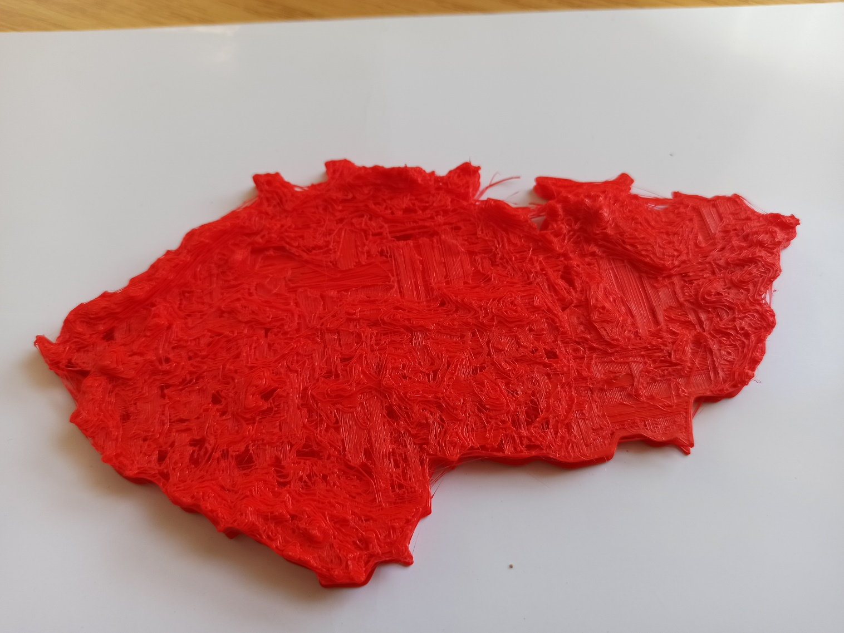

Optical illusions – physics
On Thingiverse.com, we search under the optical illusion The Squarcle: https://www.thingiverse.com/thing:2747478
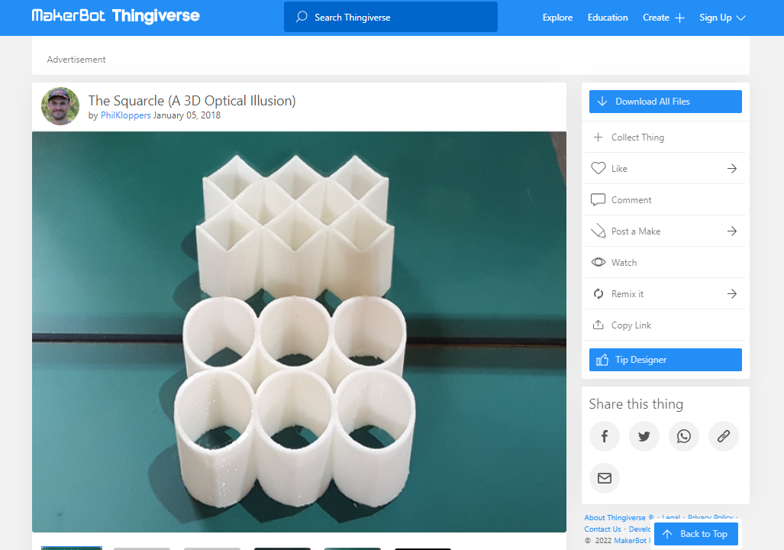
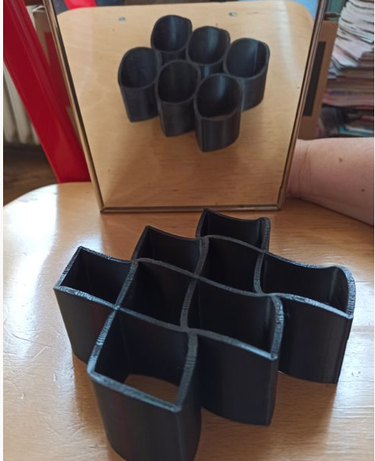

Kazoo musical instrument
The use of this tool in music education can help to remove the fear of one's own singing performance in the environment of the class collective and at the same time remain active while singing. The pupils do not intonate with their distinctive voice colour, but in unison using the kazoo instrument. Everyone can master the technique of the game, the intonation is the same as in normal singing.
Sources of STL print files:
https://www.thingiverse.com/thing:3114202/files
https://www.prusaprinters.org/cs/prints/65397-kazoo
The tool consists of 3 parts (chimney-shaped sound body, washer and threaded nut), where printing the kazoo body can be problematic due to its small base and greater height. In order to minimise the risk of the object being pulled sideways by the print head, it is recommended to turn on the automatic creation of the collar (brim) in the first layer of the printed model. The collar will increase our adhesion to the printing mat.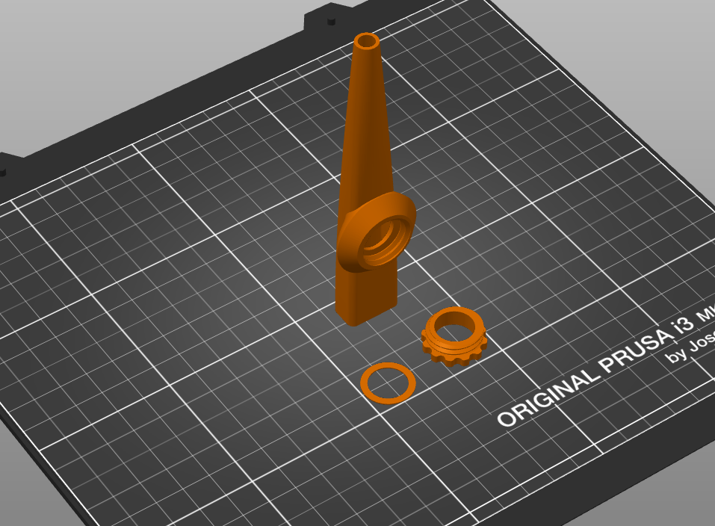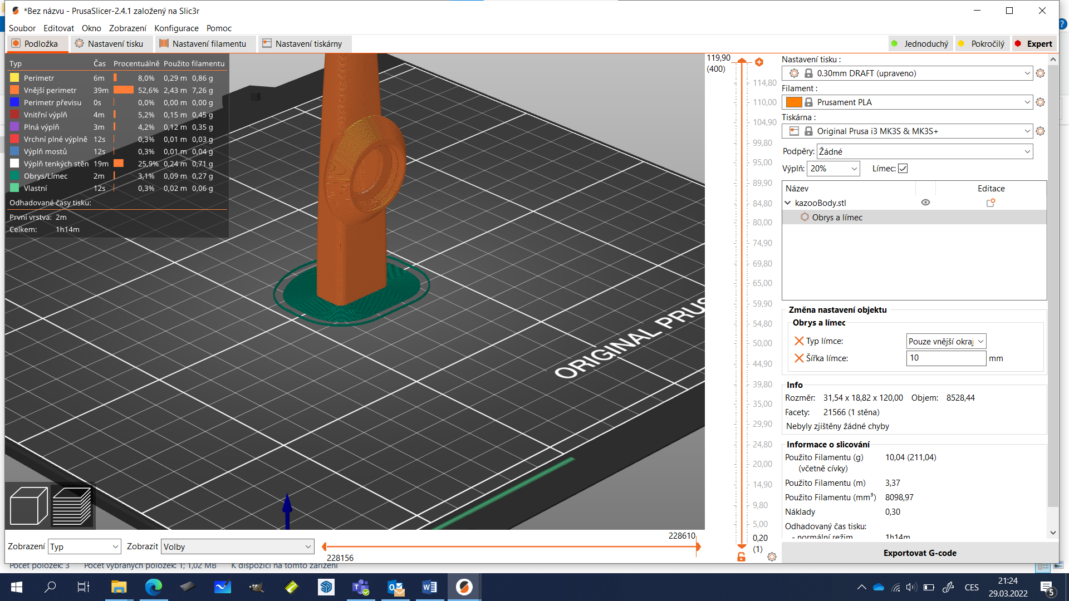

Custom creation of the model
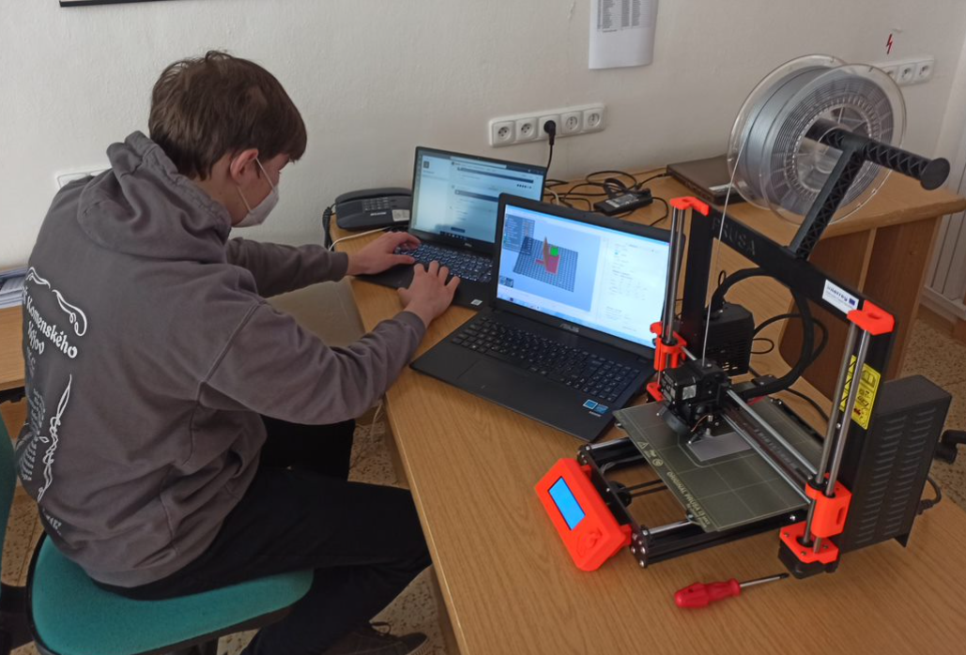
The next stage that students can go through is not only downloading the finished model, but also designing their own gadget. There are a number of programs for creating 3D models:
- Fusion 360
- AutoCAD
- Blender
- Adobe Dimension
- Inventor
- Maya
- SolidWorks
- OnShape
- Adobe Aero
- SketchUp
- Tinkercad
- Freecad

The highest quality programs are paid for, but companies quite often provide licences for schools for free or on favourable terms (e.g. SketchUp – a limited version is free online, and the full version is free for one year for schools). That was our choice together with the Tinkercad environment.

Tinkercad
It is a suitable and easy editor of 3D objects even for children, it is free and does not require installation, it automatically saves all projects in progress for possible further work with them, it is necessary to register using any e-mail address (ideally with a different password than the e-mail itself ).
https://www.Tinkercad.com
Video tutorials for working with the 3D editor:
Basics of modelling in Tinkercad:
https://www.youtube.com/playlist?list=PLhriCvfs7-z2KF_hfQYa19fOZRQB6OM8F
IT STEP PRAGUE: Tinkercad comprehensible instructions for children (50 minutes) (from time 15:
https://www.youtube.com/watch?v=U_Klc3GHIX4&t=930s
For beginners, it is an advantage that the program has short lessons for understanding the basic rules for 3D programming.
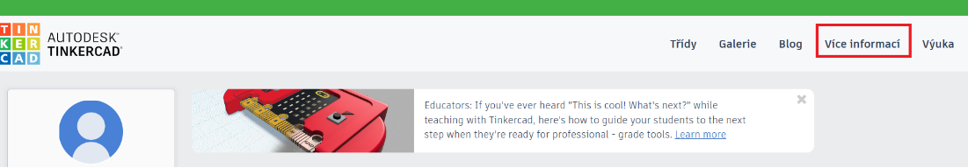

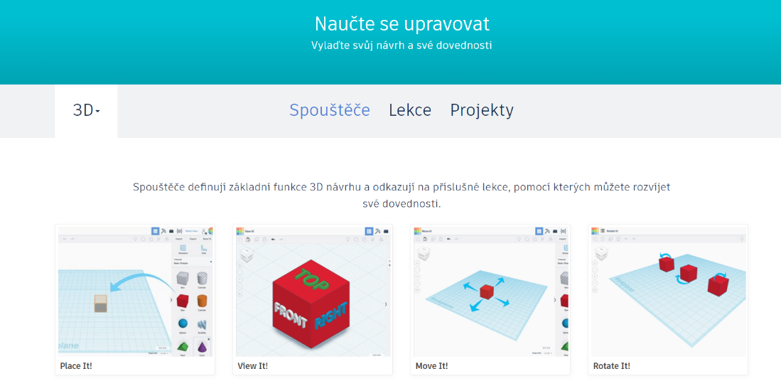
The lessons will perform basic adjustments, such as inserting an object, changing its size, rotating, creating a "hole", etc.
For lecturers, in turn, the possibility to create a class in which all student projects in progress are stored.

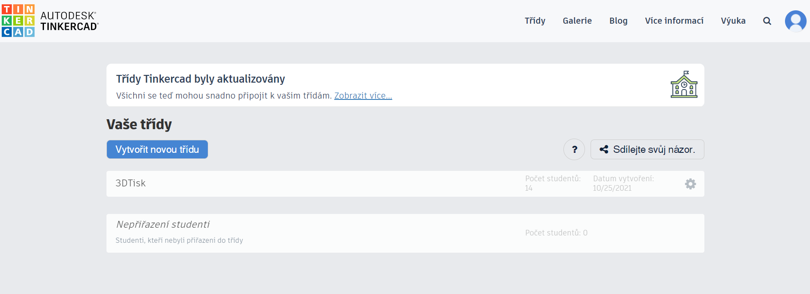

Cube
As one of the first models usable in teaching and simple for modelling is the cube representing 1 cm3, 1 dm3. The user creates a new project.
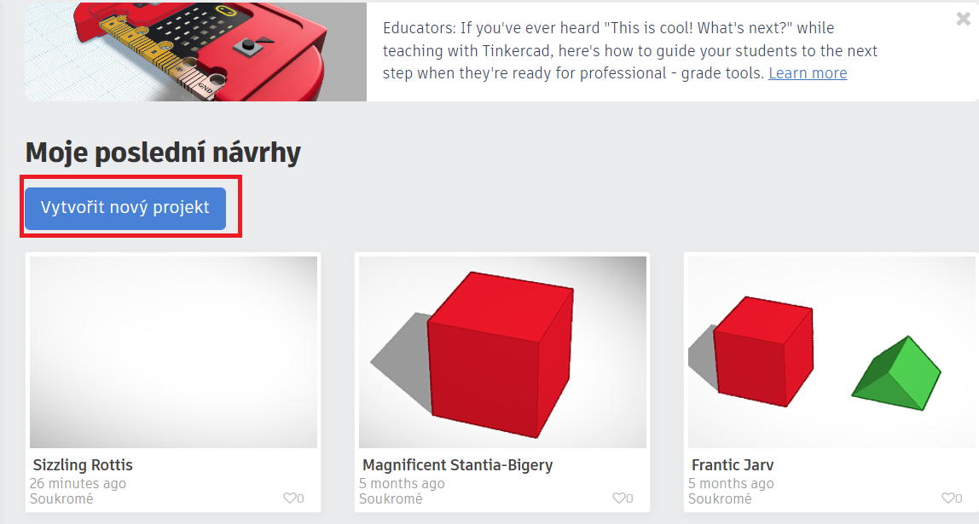
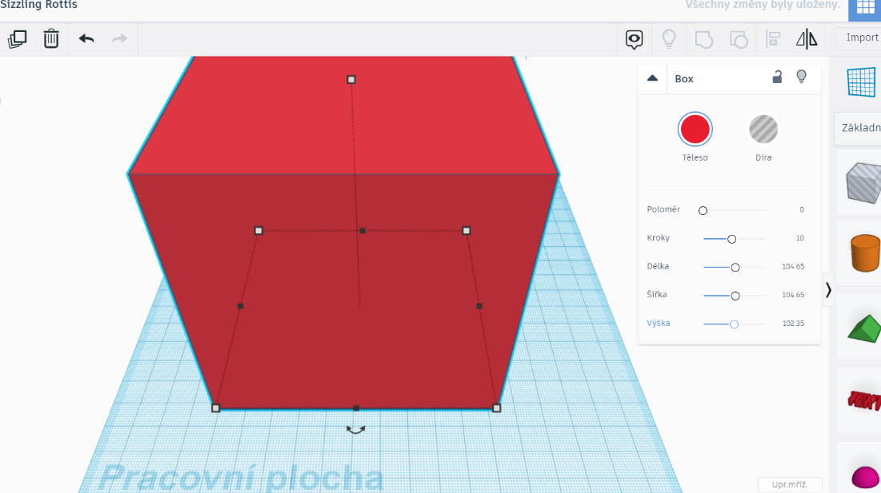
We create a cube by dragging, whose dimensions we increase to the desired length. If we only want a cube model of a given size, the dimensions will be exactly 100 x 100 x 100.
In the event that we require a cube with a volume of 1 dm3, students must realise that if they want to have internal dimensions of 100 x 100 x 100 mm, the external dimensions must be larger (how big depends on how wide the walls are required). By inserting the "hole" object, we create a hollow cube, which can be filled with water, for example.

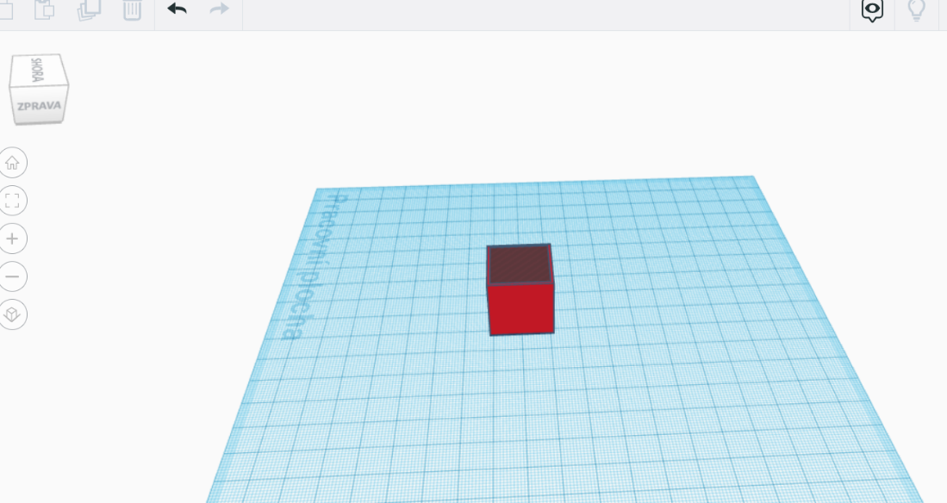
The finished model can be downloaded and prepared for 3D printing in the PrusaSlicer program.
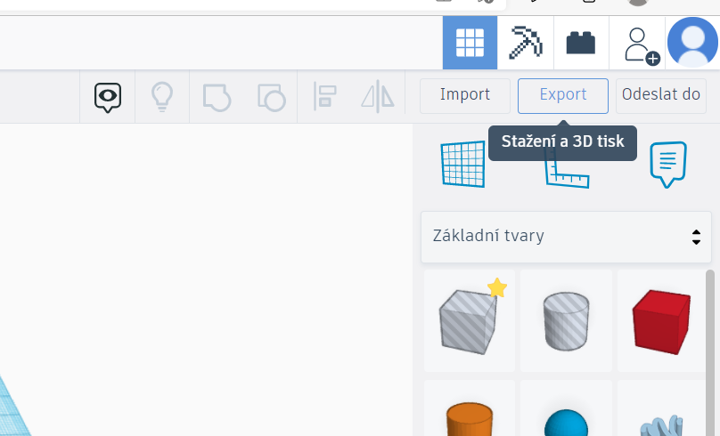
The resulting product in different colours
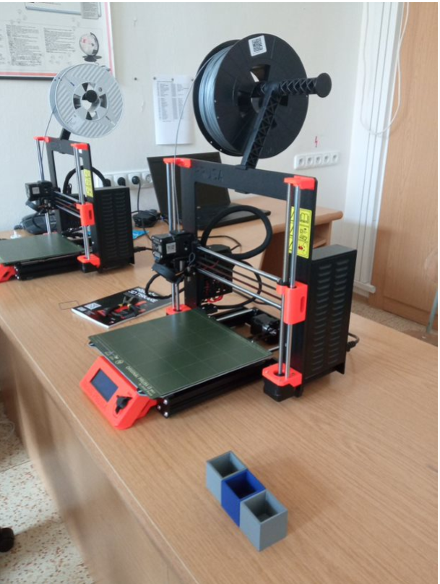
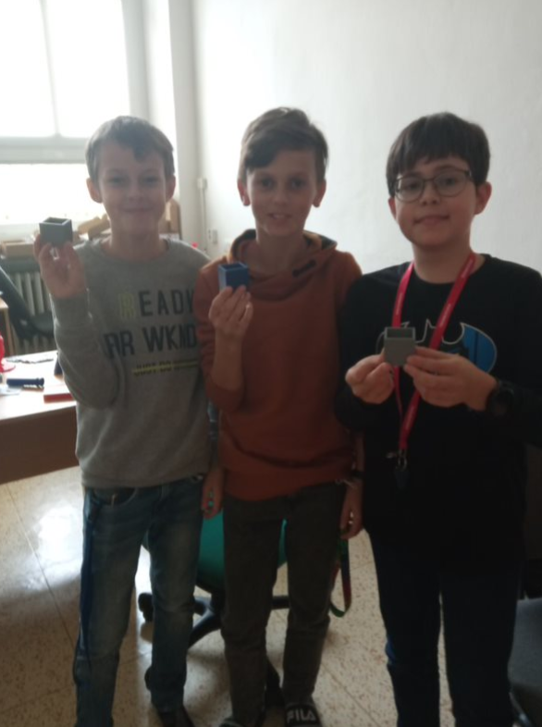

Ruler
Another project might be to create a simple ruler:
We will create an object, which is a cuboid, on which we will then create individual parts using text.
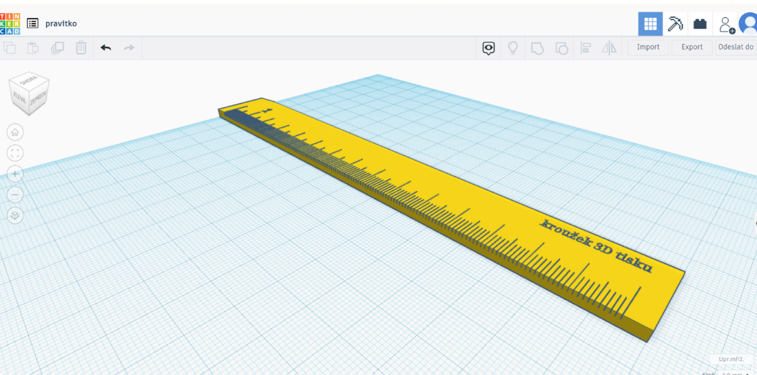
Object download and slicing:

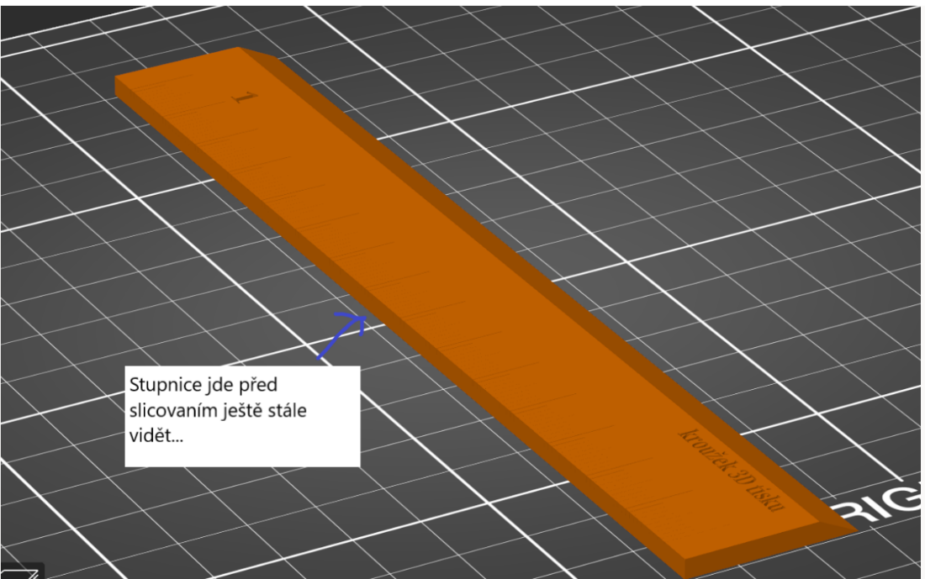
Measurement scale is still visible before slicing

SketchUp
Learning Resources:
Video course: https://www.youtube.com/channel/UC3E2gk0qrwZO1IGnALg3Zjg/videos
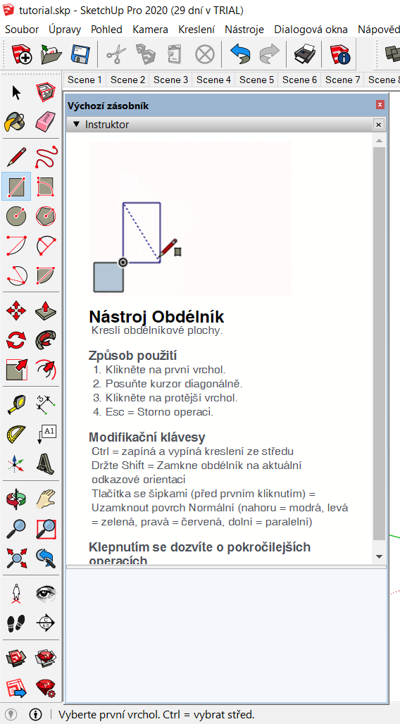
Interactive Animated Help Instructor, part of SketchUp: Displays help for the currently selected tool.

Phone stand
The pandemic and start of distance learning, in which many of our educators made their first experience with online teaching in Teams, soon showed that it is easier to conduct a lesson on two display devices at the same time. Apart from the computer, everyone owned a mobile phone and thus appreciated the design of the stand, where he placed the phone and could thus more effectively include it in distance learning. The design was implemented by the students in the SketchUp 3D editor environment. For a simple model, they used the Line tool for creating straight edges and Push/pull tool. For a more accurate construction, they also used the auxiliary construction lines of the measuring tool (Tape measure).
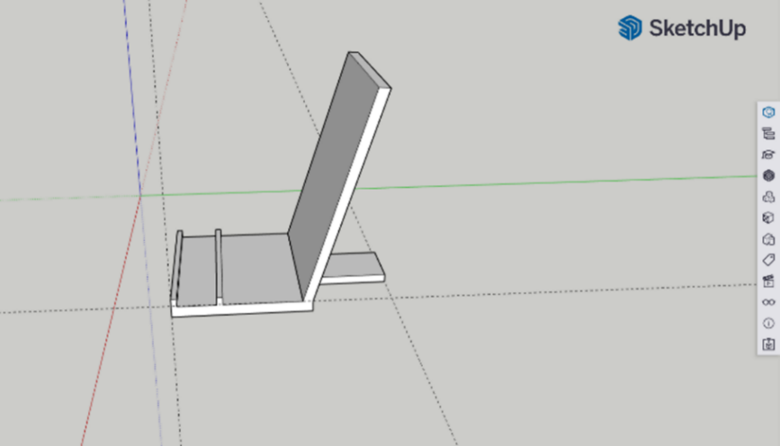
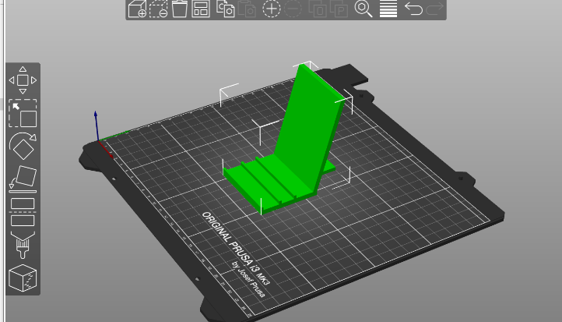
Through the Team's video conference software, we also live monitored the operation of the 3D printer in our absence, if for some reason the printing did not go as expected and it was better to stop it.
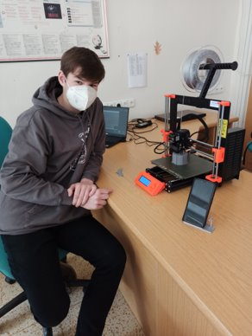

Organiser
Another 3D printed object that arose from the representative's request to be able to practically and clearly organise the information signs pinned to her office door was a simple organiser. The pitfall of printing in this model is the bridging area between the corner legs, where we could use supports (not economical), or turn the object 180° with the legs up and the upper frame on the printing mat, or print 4 separate walls and then glue them. The economic point of view, i.e. primarily the consumption of filament, should always play a fundamental role in the design of a printed object.
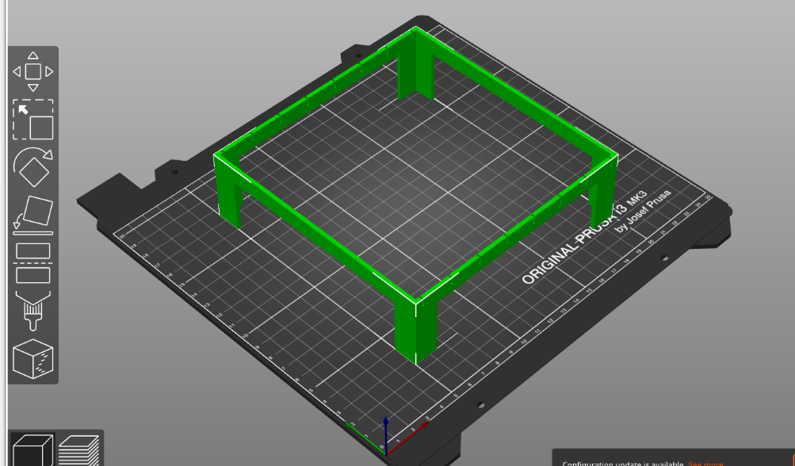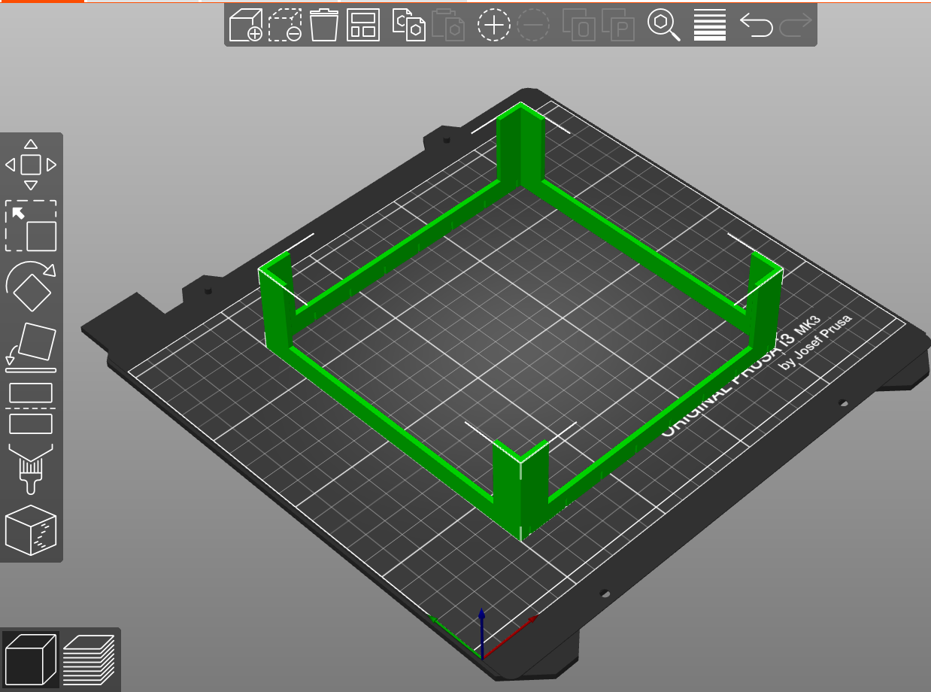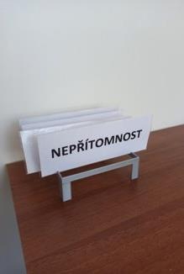

Connected vessels
This tool for physics lessons was completed by students in three parts. In the SketchUp environment, they modelled a regular hexagonal prism without an upper base and created a circular hole in its lower part for connection with a cylindrical coupling to its copy. The connection of all three parts was made with a second glue. The Polygon (N-gon) tool was used for modelling, followed by dragging in the direction of the vertical blue z-axis. The tube in the shape of a cylinder was created similarly, with the difference that it came out of the shape of a circle.
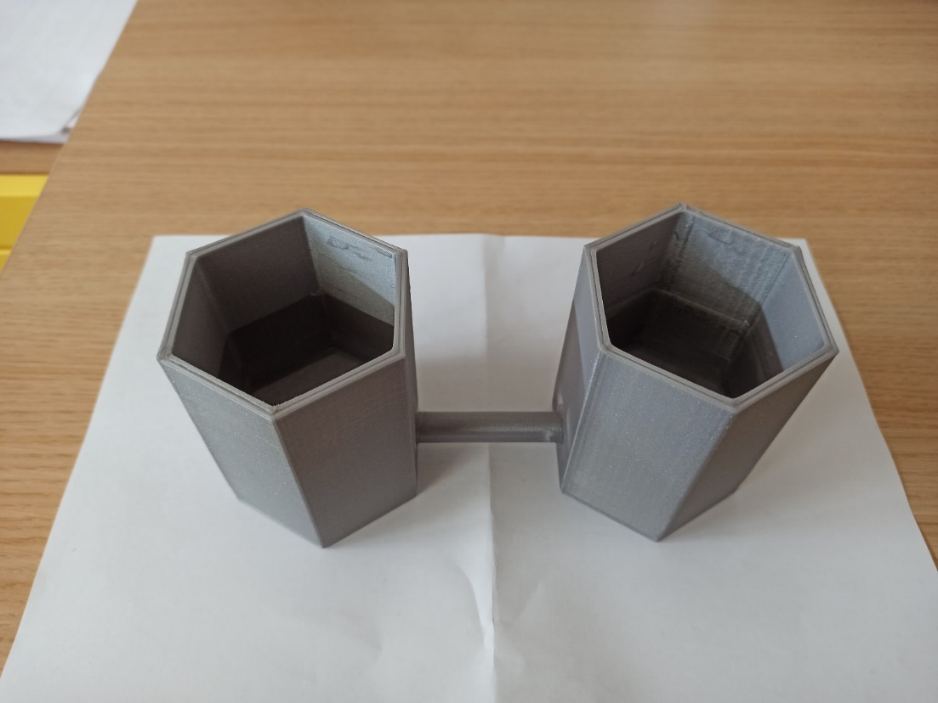
The students also tried to process this assignment in the Tinkercad environment, with the aim of printing it as one complete object without the need for gluing.
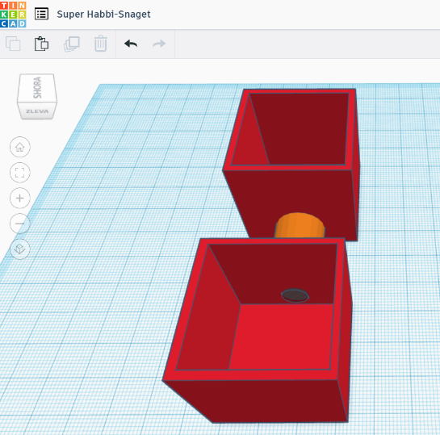
Creating the "hollow cubes" itself was not difficult. The problem arose when connecting them using a tube. We would point out to future printers, first of all, the necessity to really "blend" the tube all the way to the inside of the entire cube. If it was guided only from the surface, then during printing there was a situation where an empty space was created between the cube and the tube and the print was therefore not compact.

Fraction calculator
This is an older type of didactic aid that has been proven many times by mathematical practice and is used especially for forming the idea of ​​a fraction, comparing fractions and numerical operations with fractions. It was mainly produced in a two-dimensional design, most often with fragments of square and rectangular shapes or circular cross-sections. As part of the project, we tried to print fractions where the whole had the shape of a circle, rectangle or square.
When creating a rectangular or square fraction box, we can start from a rectangular shape in SketchUp. We will create it with the Rectangle tool and use the Offset tool to model its smaller inner copy. Use the Push/Pull tool to pull the area between the larger and smaller rectangle upwards into a cuboid without an upper base. Next, we simply copy the necessary number of objects prepared in this way and place them right next to each other. We produce stones representing a fraction of the whole in two variants, depending on whether it is the outer or the inner part of the fraction.
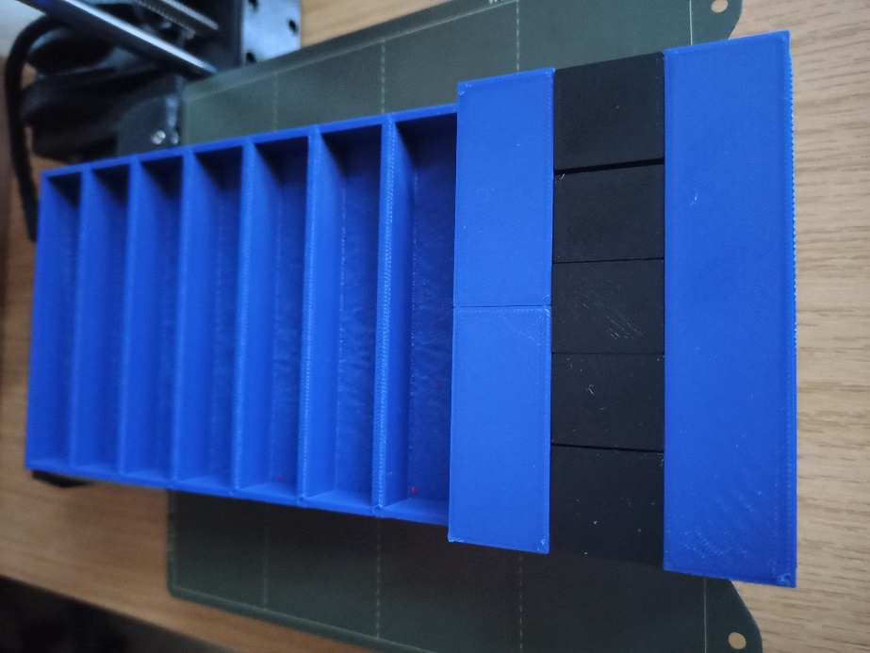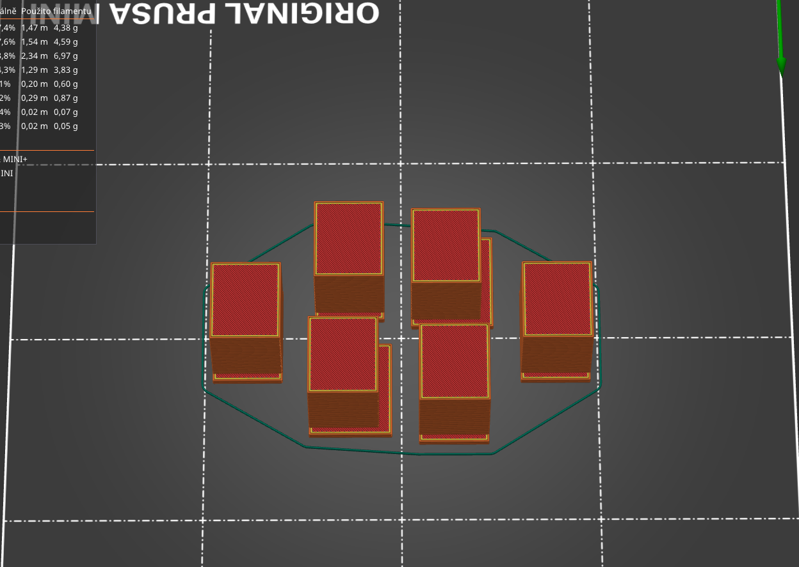
We use the Circle tool to model the fraction box with a circular floor plan, and use the Push/Pull tool to pull it upwards into a cylinder shape. Then, on the upper base, with a slight overlap inwards and outwards over the edge of the cylinder, we will place a geometric shape, which will be created as an upwardly drawn annulus. Use the 3D Text tool to create descriptions in the upper base. Similarly, using the Slice tool, we will model individual fractions. We create bowls for storing fractional parts in a similar way to the original unit, with the difference that we press down the inner part of the annulus.
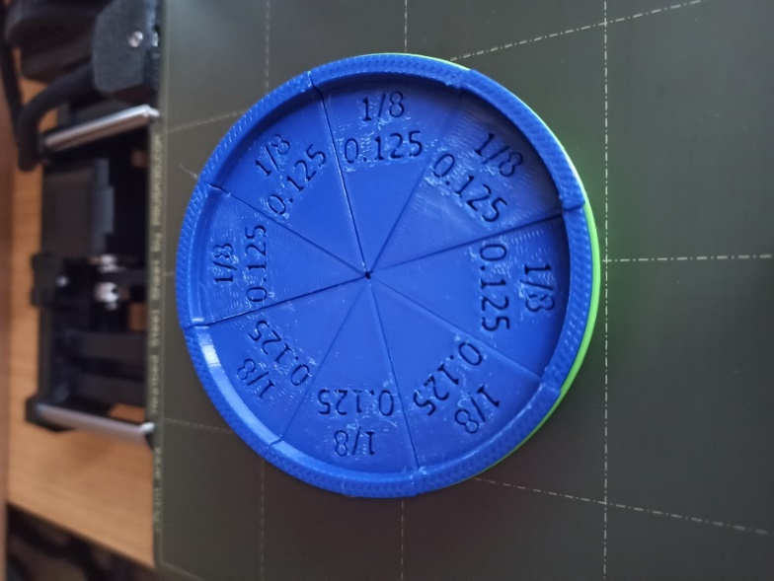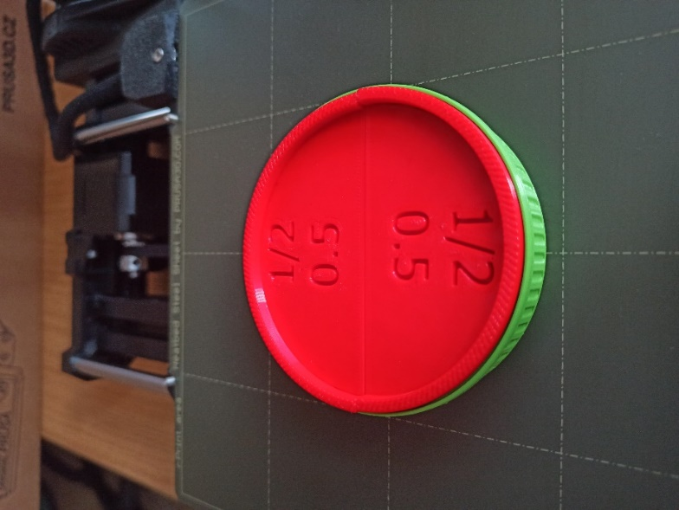
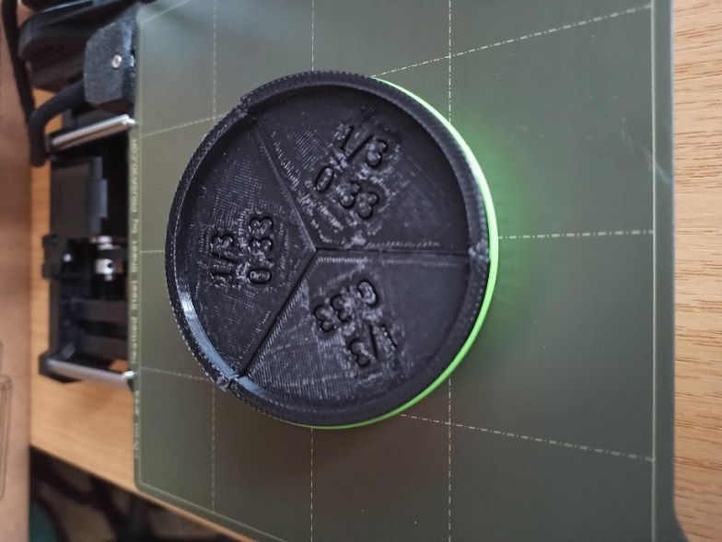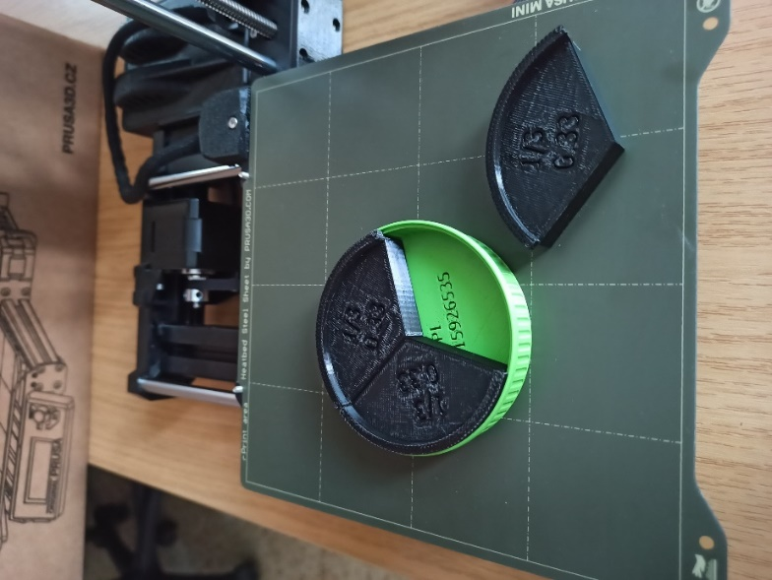

Project output
We included the created aids in the teaching.
Seventh-grade students (7th A students in the photo) tried comparing fractions and adding fractions using a fraction book.
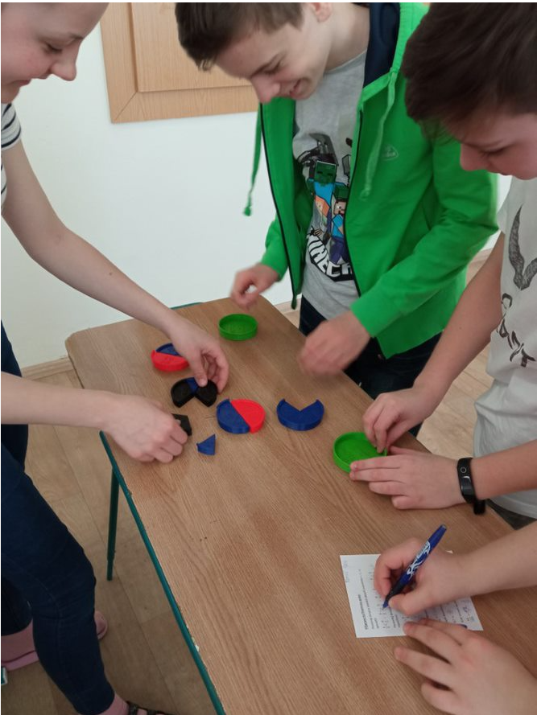
Sample worksheet:
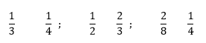
Ex. 1 Compare: Ex. 2 Add up:
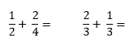

Summary of work
In the words of a student: Watching the printing process is better than television.
During the implementation of the project, students and teachers discovered a number of programs and links to creation and subsequent 3D printing. They gained the most experience from the following programs: PrusaSlicer, SketchUp and Tinkercad.
Working in 3D programs is not a common part of teaching in primary schools. Both modelling and 3D geometry were new experiences for all participants. The fact that the designs could then be printed and everyone could watch the transformation of the design into a real and useful thing moved the whole work to a higher level.
However, we also ran into problems during implementation. The Covid-19 pandemic and the associated restrictions were just one of them. Another problem was managerial work with pupils on the preparation and implementation of individual prints. Since these are very individual works of individual pupils, organising everything from the idea, through the design to the printing itself was very challenging. Other problems arose from printer errors.
But all the problems were new challenges for us. When you start working on a project, we recommend accurate phasing. From the idea, the sketch and the modelling process, through the modelling itself to printing. When the printers do not print as they should, or report errors, we recommend reading the instructions from the manufacturer Prusa Research itself. All instructions are clearly laid out, either in printed form or as video instructions.

